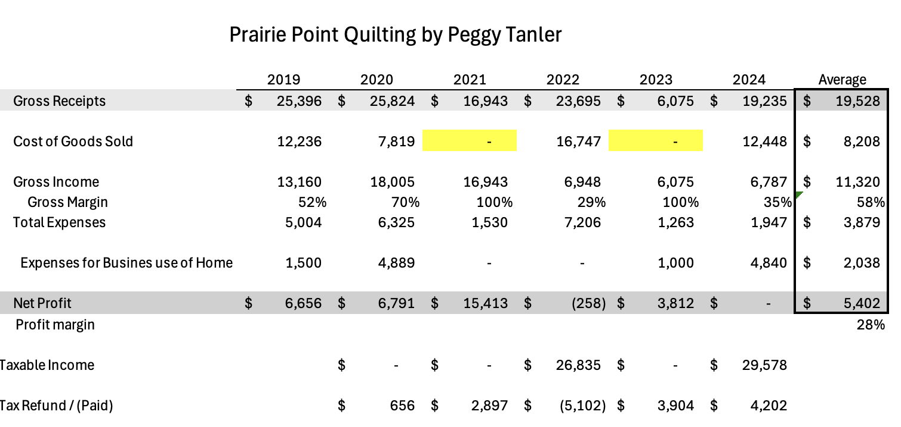

Prairie Point Quilting was an ersatz business; Peggy’s alter ego. It enhanced Peggy’s reputation within the quilting community.

Our financial goal was to ensure that this ersatz business did not increase our income taxes in retirement e.g. increase the taxable portion of our Social Security benefits. The business was relocated when we moved from Eden Prairie to Waconia in 2019. The summary above is from our joint federal income tax filings. Only in 2022 did we have to pay income taxes. This was a result of a distribution from the IRA account, an account we maintained jointly. Note: we bought the Waconia house in 2019. The business, produced an average profit of $5,402 per year, (2019 -2024). because the business paid no salaries. The net profit generated from the business was included as income on our joint tax filing. The business never filed Income Taxes as an independent entity. Was never subjected to an accounting audit. Has no audited income statement or balance sheet for the entire period of operation. It was simply an extension of Peggy’s hobby. Peggy quilted numerous quilts but never sold a quilt. She gave quilts to family members. Peggy was a textile artist not a business person her passion was the pursuit of her hobby, not operating a business.

